Greenhouse

Setup Guide

Version 1.0
[20 August 2017]

Step-by-step Guide

Contents
LIST OF ILLUSTRATIONS
Overview of Greenhouse
Setup Twilio
Create Twilo Account
Create a New Twilio API Key
Configure Twilio Phone Number
Enable Global SMS
Install Twilio py in your raspberry pi terminal
Setup AWS
Create new AWS account
Sign into the AWS IoT Console
Create and Register your raspberry Pi as “Thing”
Copy Rest API endpoint of your “Thing”
Create Certificate
Create a Security Policy for your RPI
Attach Security Policy and Thing to your Cert
Install the AWS Python Library
Setup Firebase
Create Firebase Account

LIST OF ILLUSTRATIONS

Figure
Figure 1: Sign Up Page
Figure 2: Phone Verification
Figure 3: Verification Code
Figure 4: Project Name
Figure 5: Twilio Account SID
Figure 6: Create New API Key
Figure 7: New API Key
Figure 8: Success Message
Figure 9: Get Phone Number
Figure 10: Get Twilio Number
Figure 11: Random Twilio Number
Figure 12: Twilio Number
Figure: 13: Global SMS
Figure 14: Sign Up Page
Figure 15: Role Page
Figure 16: Sign Up Page
Figure 17: Verify Page
Figure 18: Confirmation Email
Figure 19: AWS Service
Figure 20: AWS IoT
Figure 21: Things
Figure 22: Register a Thing
Figure 23: Create Thing
Figure 24: Details Page
Figure 25: REST API
Figure 26: Security
Figure 27: Certificate Page
Figure 28: Certificated Created
Figure 29: Rename of files
Figure 30: Activated Successfully
Figure 31: Attach a policy
Figure 32: New Policy
Figure 33: Configuration Steps
Figure 34: Overall Configuration
Figure 35: Going back to Previous Page
Figure 36: Nav Bar
Figure 37: Attach Policy
Figure 38: Attach policy to Certificate
Figure 39: Attach Thing
Figure 40: Attach Thing to Raspberry Pi
Figure 41: Get Started
Figure 42: Welcome Page
Figure 43: Firebase Script
Figure 44: Firebase Script
Figure 45: Firebase Database

Overview of Greenhouse
A system that helps to sustain plant life automatically without human intervention.

Setup Twilio
Twilio is a cloud communications platform as a service company that allows software developers to programmatically make and receive phone calls and send and receive text messages using its web service APIs.
Create Twilo Account
- First create an account in https://www.twilio.com/try-twilio
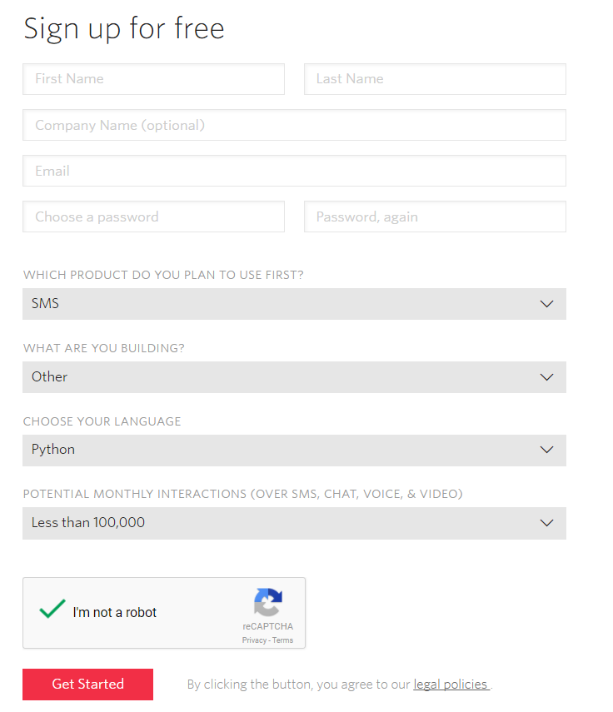
Figure 1: Sign Up Page
- Enter your phone number to verify
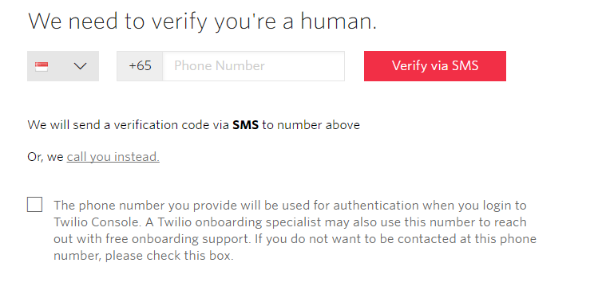
Figure 2: Phone Verification
- Enter your verification code
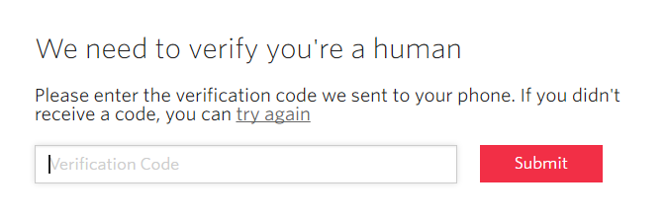
Figure 3: Verification Code

- Create a Project name. For this, we going to name the project as ‘Greenhouse’
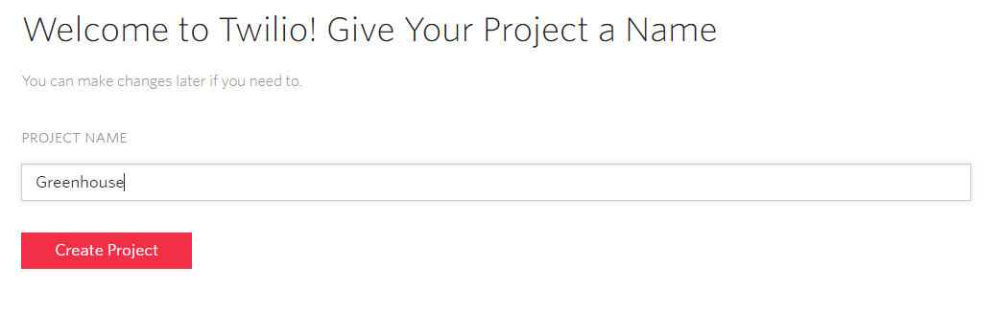
Figure 4: Project Name
- Copy your Twilio Account SID which will shown on the dashboard when you login in.
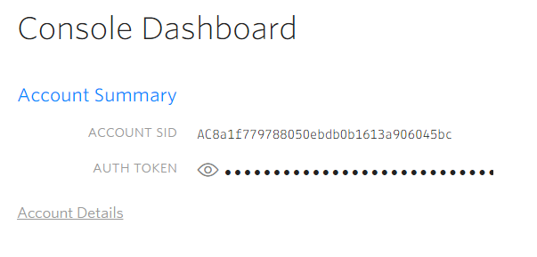
Figure 5: Twilio Account SID
Create a New Twilio API Key
- Go to “Developer Centre API Keys” and click “Create new API Key”
Figure 6: Create New API Key
- Name it as ‘ca2-greenhouse’
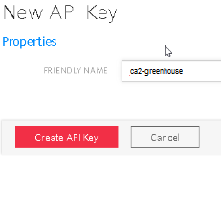
Figure 7: New API Key
- You should see a success message as you in the figure below. Copy and paste the details on a notepad and keep in safe in your desktop.
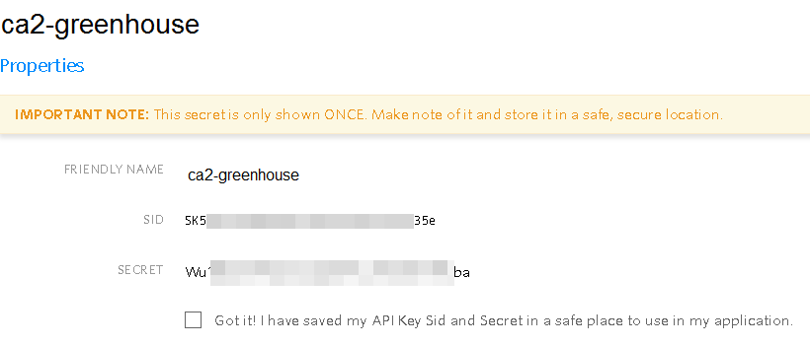
Figure 8: Success Message

Configure Twilio Phone Number
- Now get yourself a Twilio phone number. As you see the figure below, Go to “All Products & Services” and choose “Phone Numbers”.
Figure 9: Get Phone Number

- Choose “Get Started” and “Get your first Twilio phone number”
Figure 10: Get Twilio Number

- After you choose get started you will be assigned a random Twilio USA telephone number. That’s ok, just click “Choose this number”
Figure 11: Random Twilio Number

- Copy the phone number as you will need it later
Figure 12: Twilio Number
Enable Global SMS
- Since you got a USA-based telephone number in the previous section but we will be sending SMS to your Singapore-based handphone number, you will also need to configure permissions for global SMS at https://www.twilio.com/console/sms/settings/geo-permissions . Be sure to add Singapore in the “Geo-Permissions” section.
Figure: 13: Global SMS

Install Twilio py in your raspberry pi terminal
- sudo pip install twilio
- sudo pip install twilio-python

Setup AWS
AWS Educate is Amazon's Programme to help students learn real‐world cloud technology skills
before graduating. Under this programme, students will get a renewable annual credit of USD100
of AWS services. No credit card is necessary to sign up for this account. However, once you have
used up the USD100 credit, your account will automatically be rendered unusable.
Create new AWS account
- Access AWS Educate website: https://aws.amazon.com/education/awseducate/apply/ . Select “Students” option as you see the figure below:
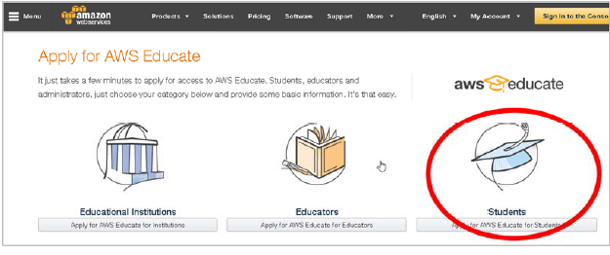
Figure 14: Apply for AWS Page
- Select Role as “Student”
Figure 15: Role Page

- On the sign up form, ensure the following (the one in red box) setting are specified, and fill in the rest of the form as appropriate and then click next button as you see in the figure below.
- Institution Name “Singapore Polytechnic School of EEE”
- Email should be SP ichat email address
- Make sure “Click here to select an AWS Educate Starter account” is selected and not the other one.
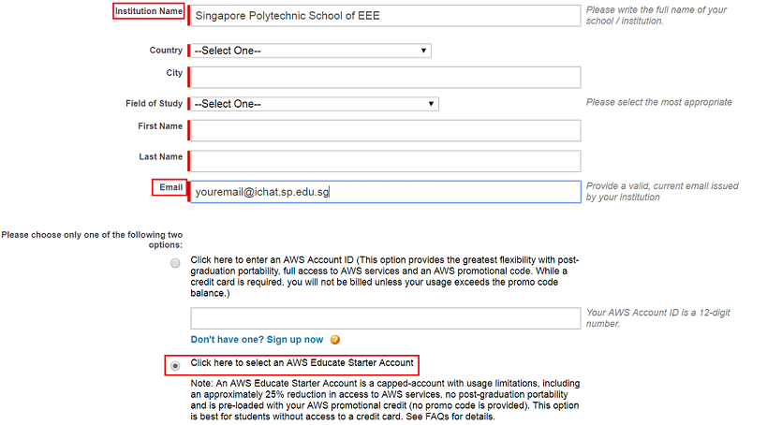
Figure 16: Sign Up Page
- Follow the instructions to verify your account by providing a verification code that is sent to your ichat account
Figure 17: Verify Page
- Once your AWS account is ready to use, you will receive an email similar to the figure you see below:
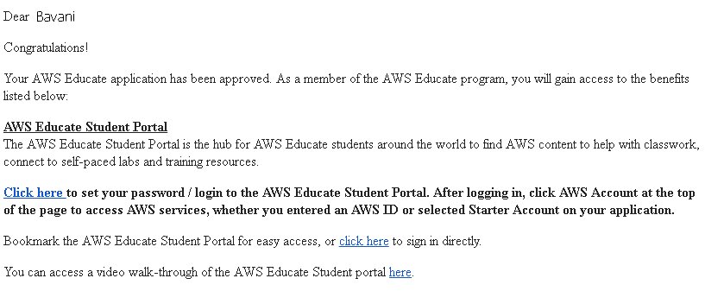
Figure 18: Confirmation Email
Sign into the AWS IoT Console
- Turn on your Raspberry Pi
- Sign in with your AWS Console at https://aws.amazon.com
- In the AWS dashboard, type “AWS IoT” to access the AWS IoT service
Figure 19: AWS Service
- On the Welcome page, choose “Get Started”
Figure 20: AWS IoT
Create and Register your raspberry Pi as “Thing”
- In the left navigation pane click “Registry to expand it, then select ‘Things”
Figure 21: Things
- On the page where it state “You don’t have any things yet”, select “Register a thing” and if you have already created a thing before, then choose “Create”
Figure 22: Register a Thing
- A thing represents a device whose status or data is stored in the AWS cloud. The Thing Shadows is the state of the device, eg: is it “on” or “off” is it “red” or “green” etc.

- Our “Thing” here is our RPI, so let’s name it as RaspberryPi and click “Create thing”
Figure 23: Create Thing
Copy Rest API endpoint of your “Thing”
- On the Details page, Choose Interact.
Figure 24: Details Page
- Copy and paste the REST API endpoint into a notepad as you will need it later
Figure 25: REST API
Create Certificate
- Next select “Security”
Figure 26: Security
- Select “Create certificate to generate an X.509 certificate and key pair”
Figure 27: Certificate Page
- After a while, you should see the screen as you see in the figure below, where there is a total of 4 download links
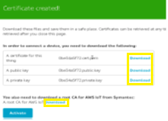
Figure 28: Certificated Created
- Create a folder called devieSDK (or any name you preferred) and download all the 4 files into the folder and rename them all with friendly names like what you see in the figure below:
Figure 29: Rename of files
- Next, click the “Activate” button. Almost immediately, you should see “Successfully activated certificate” and the Activate button changes to “Deactivate”

Figure 30: Activated Successfully
Create a Security Policy for your RPI
- Next, click on the “Attach a policy” button that is near the bottom right‐hand corner of the page.
Figure 31: Attach a policy

- On the next page, choose “Create new Policy”
Figure 32: New Policy
- On the Create a policy page, key in the following configuration and then click “Create”
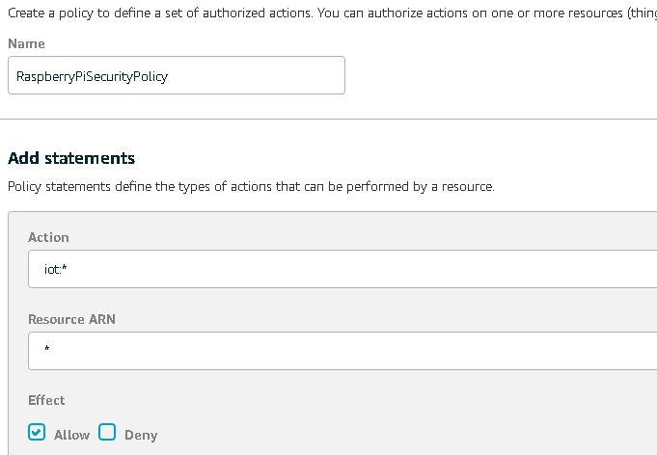
Figure 33: Configuration Steps
- The figure below shows the full configuration
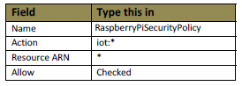
Figure 34: Overall Configuration
- You will see a page like the figure below, move ahead to clock the “Back” arrow to return to the previous page and continue with the instructions in the next section
Figure 35: Going back to Previous Page

Attach Security Policy and Thing to your Cert
- On the left nav bar, click “Security” than “Certificates”
Figure 36: Nav Bar
- The X.509 certificate you created earlier is shown. Click the checkbox besideit, then click “Actions” button and choose“Attach Policy”
Figure 37: Attach Policy
- Check the “RaspberryPiSecurityPolicy” you created earlier and click “Attach” button.
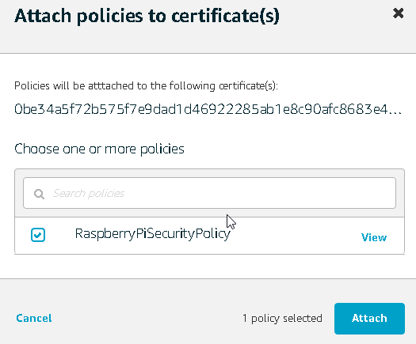
Figure 38: Attach Policy to Certificate

- Let’s attach the “Thing” to this certificate. Click “Actions” button and choose “Attach Thing”
Figure 39: Attach Thing
- In the Attach things to certificate(s) dialog box, select the check box next to the thing you created to represent your Raspberry Pi, and then choose Attach

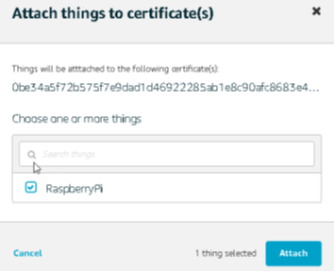
Figure 40: Attach Thing to Raspberry Pi
Install the AWS Python Library
- sudo pip install AWSIoTPythonSDK

Setup Firebase
Firebase helps user to build better mobile apps and grow their business

Create Firebase Account
- Go to https://firebase.google.com/ and click on the “GET STARTED”

Figure 41: Get Started
- After clicking “GET STARTED”, log into your Google Account After logging in with your Google Account for the first time, you’ll have a clean Firebase console created for you. Do not need to worry about forking over any money as everything covered today falls well within Firebase’s free plan.
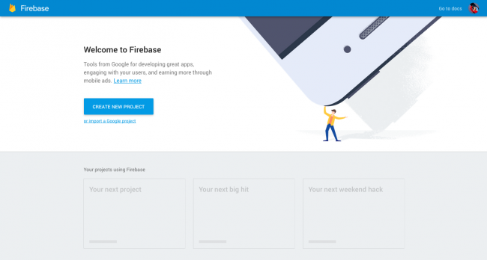
Figure 42: Welcome Page

- Click on “CREATE NEW PROJECT”, you will see a dialog box appear, enter your project name and specify your preferred Country/region;
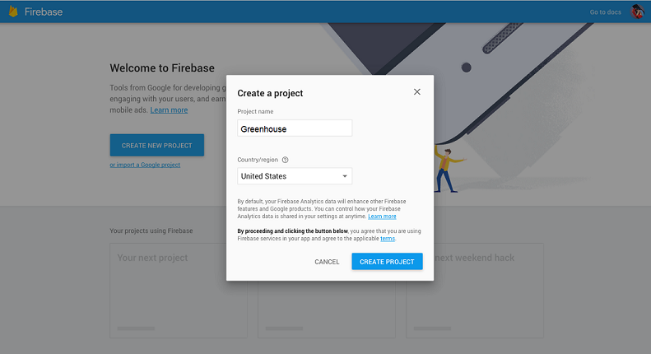
Figure 43: Create Project
- After clicking “CREATE PROJECT”, you will be taken to the dashboard where you can manage you Firebase project. Click on the “Add Firebase to your web app” You can find all the necessary connection information in your Firebase console and you can actually copy/paste this straight into your project

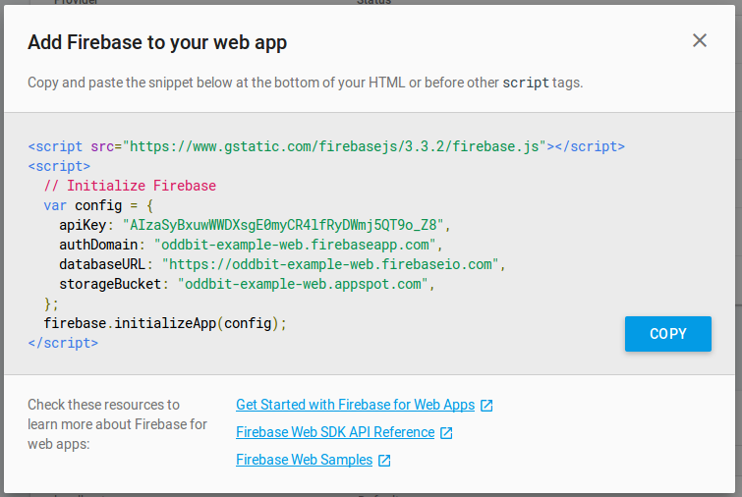
Figure 44: Firebase Script

- You can log into the Firebase dashboard and view the data in your database. Once the data is stored in the database against a user, it looks something like the figure below:
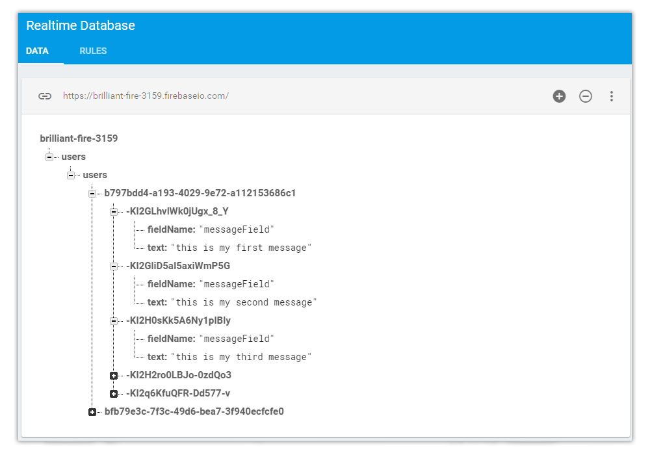
Figure 45: Firebase Database

